NEXTAG COMPANY

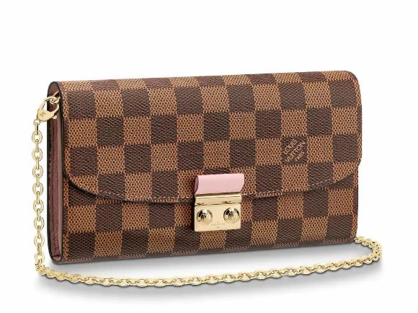LOUIS VUITTON - CROISETTE CHAIN WALLET

##### **Detail**

This reinterpretation of the Croisette handbag in Damier canvas features a colorful leather lining and an emblematic metallic clasp inspired by historic Louis Vuitton trunks. Fresh and feminine, it can be used as a large wallet or a small, chic evening pouch, either with or without its removable chain.

• 12 CC slots

• 1 zipped coin pocket

• 2 flat pockets

• 2 large gusseted compartments

• Damier Ebène coated canvas

• 19.0 x 10.5 x 2.5 cm (Length x Height x Width)

##### **CARE & COMPOSITION**

* leather
* imported